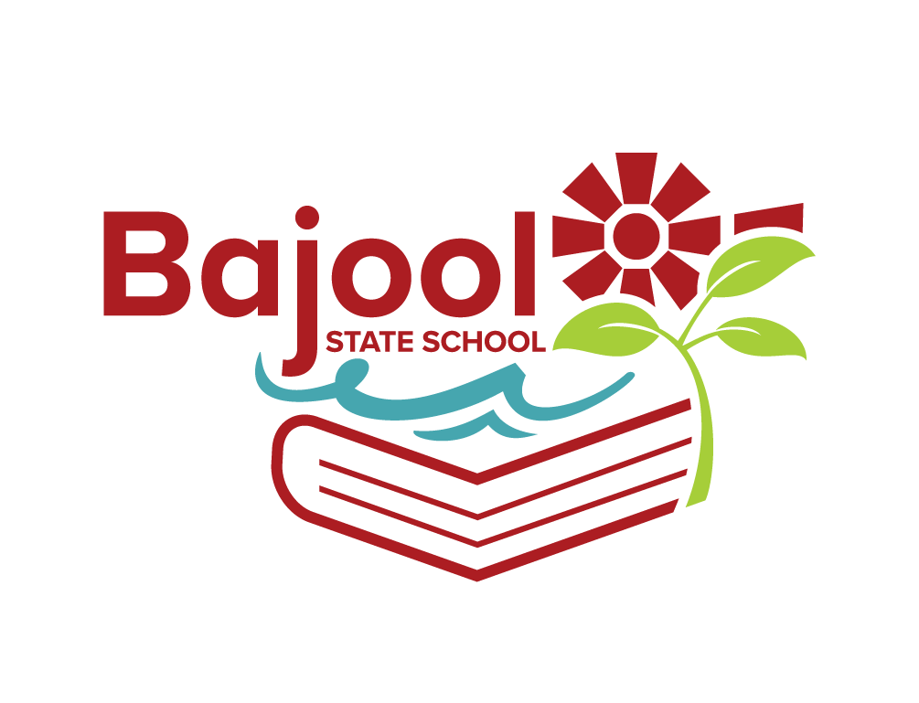
BAJOOL STATE SCHOOL 2024 BOOKLIST
Year 4

Please label all items clearly and cover books

DESCRIPTION | QUANTITY  REQUIRED
PAPERMATE PEN INKJOY MEDIUM RED | 3
SCISSORS STAEDTLER NORIS CLUB 17CM | 1
LIBRARY BAG 310 X 430 MM | 1
RULER WOODEN 30CM | 2
A4 TOPLOAD FILE (Homework folder) | 1
A4 YEAR 3/4 LINES 48 PAGE EXERCISE BOOK STAPLED | 8
A4 10MM QUAD/GRID 48 PAGE EXERCISE BOOK STAPLED | 3
A4 DISPLAY BOOK 20 PAGE REFILLABLE | 2
SCRAP BOOK OLYMPIC 96 PAGE 335 X 240MM | 1
PLASTIC MUG WITH A HANDLE | 1
HEADPHONE SET WITH MICROPHONE AND USB CONNECTION
VOLUNTARY CONTRIBUTIONS
A4 COPY PAPER WHITE 8OGSM (REAM) | 2
BOX OF TISSUES | 2
NEW ENROLMENTS WILL REQUIRE IN ADDITION TO ABOVE
SCRAP BOOK OLYMPIC 96 PAGE 335 X 240MM | 3
A4 BLUE LINED 64 PAGE EXERCISE BOOK STAPLED (for Japanese and Writing) | 2
A4 DISPLAY BOOK 20 PAGE REFILLABLE | 4
A3 PROTEXT DISPLAY BOOK 20 PAGE | 1
PAINTING SMOCK/SHIRT | 1

BAJOOL STATE SCHOOL WILL PROVIDE THE FOLLOWING ITEMS
FELT PENS, COLOURED PENCILS, GEL PENS, CRAYONS, GLITTER GLUE, WHITEBOARD MARKERS, WRITING PENCILS, GLUE STICKS, ERASERS & SHARPENERS

