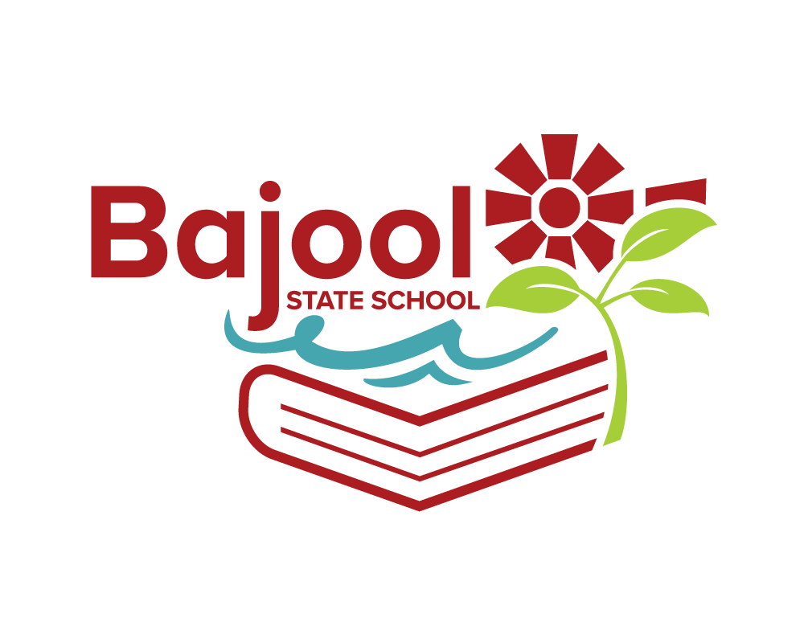
BAJOOL STATE SCHOOL 2024 BOOKLIST
Year 2

Please label all items clearly and cover books

DESCRIPTION | QUANTITY REQUIRED
PAPERMATE PEN INKJOY MEDIUM RED | 3
SCISSORS STAEDTLER NORIS CLUB 17CM | 1
LIBRARY BAG 310 X 430 MM | 1
RULER WOODEN 30CM | 2
A4 TOPLOAD FILE (Homework folder) | 2
A4 YEAR 2 LINES 48 PAGE EXERCISE BOOK STAPLED | 10
A4 10MM QUAD/GRID 48 PAGE EXERCISE BOOK STAPLED | 3
A4 DISPLAY BOOK 20 PAGE REFILLABLE | 3
SCRAP BOOK OLYMPIC 96 PAGE 335 X 240MM | 1
PLASTIC MUG WITH A HANDLE | 1
VOLUNTARY CONTRIBUTIONS
A4 COPY PAPER WHITE 8OGSM (REAM) | 2
BOX OF TISSUES | 2

NEW ENROLMENTS WILL REQUIRE IN ADDITION TO ABOVE
SCRAP BOOK OLYMPIC 96 PAGE 335 X 240MM | 3
A4 BLUE LINED 64 PAGE EXERCISE BOOK STAPLED (for Japanese) | 1
A4 DISPLAY BOOK 20 PAGE REFILLABLE | 3
A3 PROTEXT DISPLAY BOOK 20 PAGE | 1
PAINTING SMOCK/SHIRT | 1

BAJOOL STATE SCHOOL WILL PROVIDE THE FOLLOWING ITEMS
HEADPHONE SET WITH MICROPHONE AND USB CONNECTION, FELT PENS, COLOURED PENCILS, GEL PENS, CRAYONS, WRITING PENCILS, GLUE STICKS, ERASERS & SHARPENERS

